WEEK 5: WIREFRAMES USING LUCIDCHART
V.Roshini | 230701270 | CSE-FC

AIM: To understand and document the steps a user takes to complete the main tasks within an online shopping app
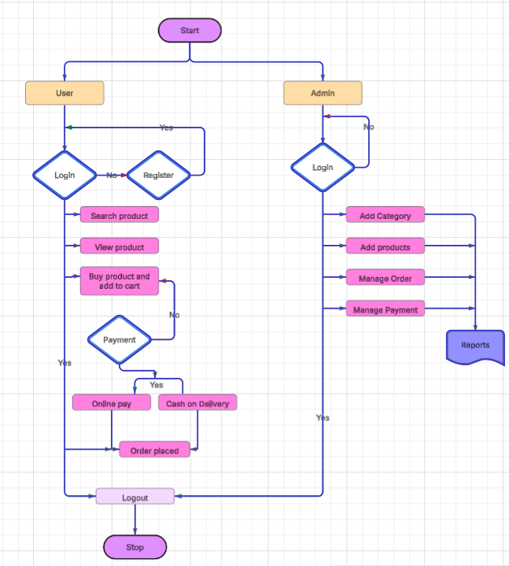
The system supports two primary roles: User and Admin
1. User Flow
The user’s journey starts with accessing the application, where they are presented with the option to either log in or register.
- Registration/Login:
  - If the user is new, they must complete the registration process before logging in.
  - Returning users can log in directly using their credentials.
- Product Interaction:
Once logged in, users can:
  - Search for products using the search function.
  - View detailed product information.
  - Select products they wish to buy and add them to the shopping cart.
- Checkout and Payment:
After finalizing the cart:
  - Users proceed to the payment stage.
  - They choose between two payment options: online payment or cash on delivery.
  - Upon successful payment or confirming cash on delivery, the order is marked as placed.
- Post-Order Actions:
Once the order is placed, the user can log out, completing their session. This leads to the end of the process.

2. Admin Flow
The admin’s journey also begins with logging in.
- Admin Login:
  - Only authenticated admins can access management functions.
  - If not already logged in, they must log in to proceed.

- Management Functions:
Once logged in, the admin can:
  - Add product categories.
  - Add new products to the platform.
  - Manage existing orders, including tracking, updating, or canceling them.
  - Handle and oversee payment processes.
- Reporting:
Admins have access to system-generated reports, which provide insights into orders, payments, and overall platform performance.
- Session Completion:
After completing their tasks, the admin logs out, ending the session.

This flow ensures that the user experience is streamlined and intuitive, allowing customers to quickly find and purchase products. Simultaneously, it equips admins with the necessary tools to manage the platform efficiently. By following this structured workflow, the application balances customer-facing simplicity with backend robustness.

